**VISVESVARAYA TECHNOLOGICAL UNIVERSITY**

**“JnanaSangama”, Belgaum -590014, Karnataka.**



**LAB REPORT**

**on**

**Object Oriented Java Programming**

***Submitted by***

**IMRAN WADRALI (1BM21CS077)**

***in partial fulfillment for the award of the degree of***

**BACHELOR OF ENGINEERING**

***in***

**COMPUTER SCIENCE AND ENGINEERING**



**B.M.S. COLLEGE OF ENGINEERING**

**(Autonomous Institution under VTU)**

**BENGALURU-560019 Oct 2022-Feb 2023**

**B. M. S. College of Engineering,**

**Bull Temple Road, Bangalore 560019**

(Affiliated To Visvesvaraya Technological University, Belgaum)

**Department of Computer Science and Engineering**



**CERTIFICATE**

This is to certify that the Lab work entitled “**OBJECT ORIENTED JAVA PROGRAMMING**” carried out by **IMRAN WADRALI (1BM21CS077),** who is bonafide student of **B. M. S. College of Engineering.** It is in partial fulfillment for the award of **Bachelor of Engineering in Computer Science and Engineering** of the Visvesvaraya Technological University, Belgaum during the year 2022-23. The Lab report has been approved as it satisfies the academic requirements in respect of Data structures Lab **- (22CS3PCOOJ)**work prescribed for the said degree.

**Dr. Vikranth B.M Dr. Jyothi S Nayak**

Assistant Professor Professor and Head

Department of CSE Department of CSE

BMSCE, Bengaluru BMSCE, Bengaluru

`

1

# Index Sheet

|  |  |  |
| --- | --- | --- |
| **Sl.**  **No.** | **Experiment Title** | **Page No.** |
| 1 | Quadratic Equation | 3-7 |
| 2 | SGPA  calculation | 8-13 |
| 3 | Book Details | 14-19 |
| 4 | Abstract Class | 20-24 |
| 5 | Bank | 25-40 |
| 6 | Interface | 40-49 |
| 7 | Exception Tree | 50-53 |
| 8 | Multithreading | 54-57 |

2

# LAB PROGRAM 1:

**Develop a Java program that prints all real solutions to the quadratic equation. ax2+bx+c = 0. Read in a, b, c and use the quadratic formula. If the discriminate b2-4ac is negative, display a message stating that there are no real solutions.**

import java.util.Scanner; import java.lang.Math;

class QuadraticEquation{

public static void main(String [] args){ int a,b,c;

int d=0;

Scanner scanner = new Scanner(System.in);

System.out.println("Enter the coefficients of the quadratic equation in the form a, b,c where ax2

+ bx + c=0");

a = scanner.nextInt(); b =

scanner.nextInt(); c = scanner.nextInt();

d = ((int)Math.pow(b,2)- 4*a*c);

double result1 = (-b + Math.pow(d,0.5))/(2*a); double result2 = (-b - Math.pow(d,0.5))/(2*a);

if(d==0){

System.out.println("The roots are real and equal"); System.out.println("The root is:" + " " + result1 );

3

}

else if(d>0){

System.out.println("The roots are real and distinct"); System.out.println("The roots are: "); System.out.println("root 1 " + result1); System.out.println("root 2" + result2);

}

else{

}

double factor = (Math.sqrt(Math.abs(d))) / (2*a); System.out.println("The roots are imaginary"); System.out.println("The roots are: "); System.out.println("root 1 " + -b/(2*a) + "+i " + factor); System.out.println("root 2 " + -b/(2*a) + "-i " + factor);

}

}

4

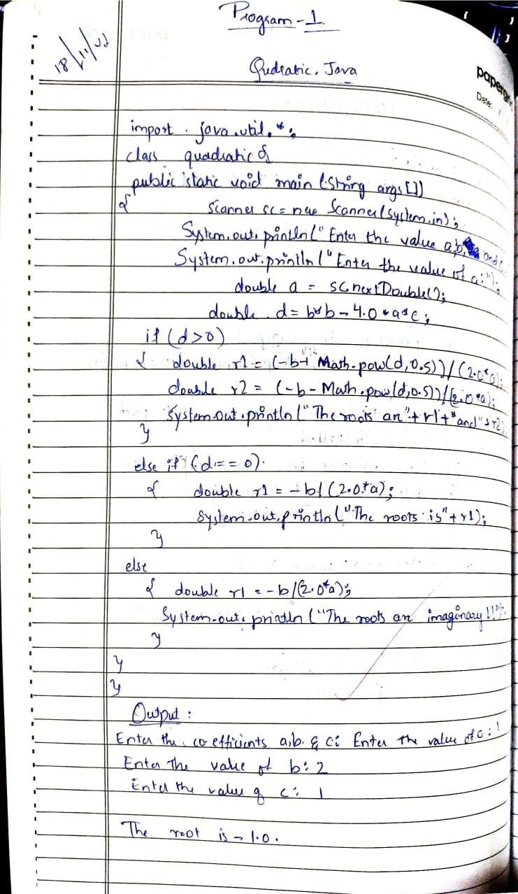

5

Output:

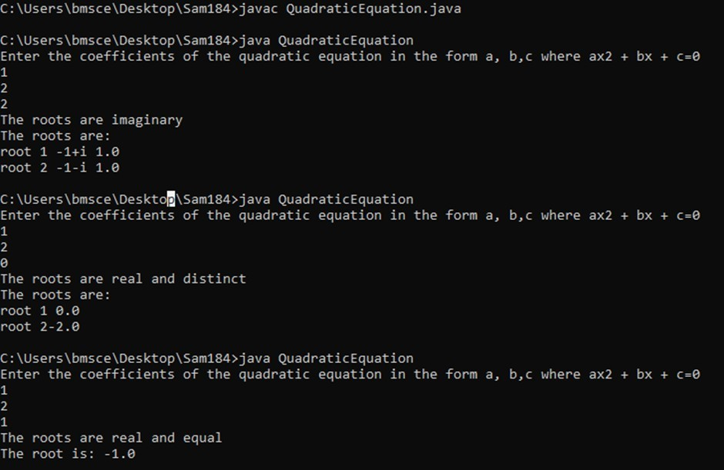

6

# Lab Program 2:

**Develop a Java program to create a class Student with members usn, name, an array credits and an array marks. Include methods to accept and display details and a method to calculate SGPA of a student.**

import java.util.Scanner; class Studentx{

Scanner s=new Scanner(System.in); private int usn;

private String name; int n;

int[] marks=new int[10]; int[] credits=new int[10]; void getMarks(){

System.out.println("Enter no of subjects:"); this.n=s.nextInt();

System.out.println("Enter marks of subjects and credits consecutively:"); for(int i=0;i<n;i++){

this.marks[i]=s.nextInt(); this.credits[i]=s.nextInt();

}

}

int[] getGrade(){

int[] grade=new int[10]; for(int i=0;i<n;i++){

if(marks[i]>=90){ grade[i]=10;

}else if(marks[i]>=80){ grade[i]=9;

}else if(marks[i]>=70){ grade[i]=8;

}else if(marks[i]>=60){ grade[i]=7;

}else if(marks[i]>=50){ grade[i]=6;

}else if(marks[i]>=40){ grade[i]=5;

}else if(marks[i]>=30){ grade[i]=4;

}else{

grade[i]=0;

}

}

return grade;

7

}

double calc(){

int sum1=0,sum2=0; for(int i=0;i<n;i++){

int[] grade; grade=getGrade();

sum1+=grade[i]*this.credits[i]; sum2+=this.credits[i];

}

return (double)sum1/sum2;

}

void display(){ System.out.println("Marks\tCredits\n"); for(int i=0;i<n;i++){

System.out.println(this.marks[i]+"\t\t"+this.credits[i]+"\n");

}

System.out.println("SGPA="+calc());

}

}

class mainx{

public static void main(String args[]){ Studentx s=new Studentx(); s.getMarks();

s.calc();

s.display();

}

}

8

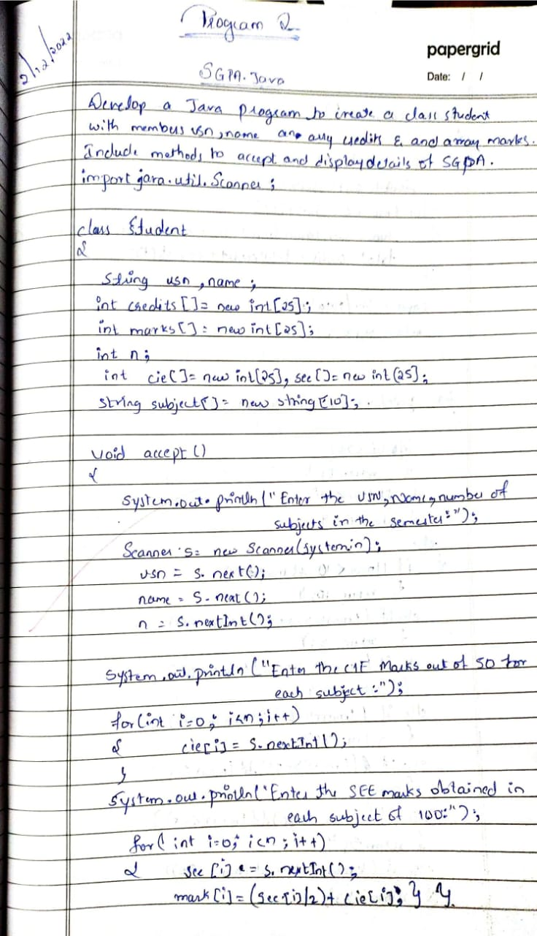

9

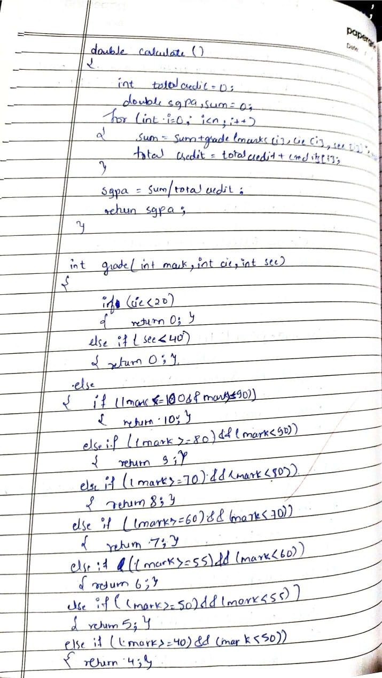

10

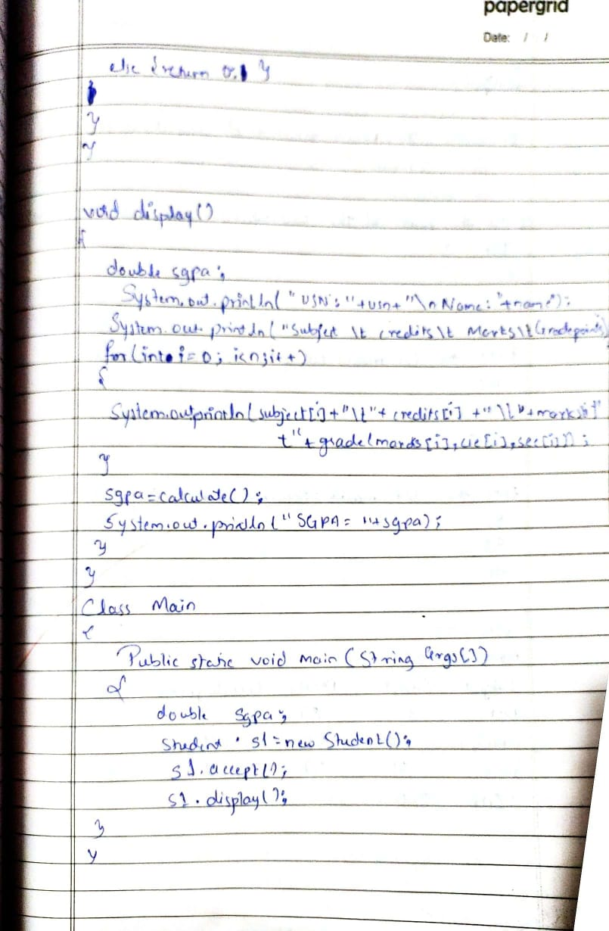

11

# Output:

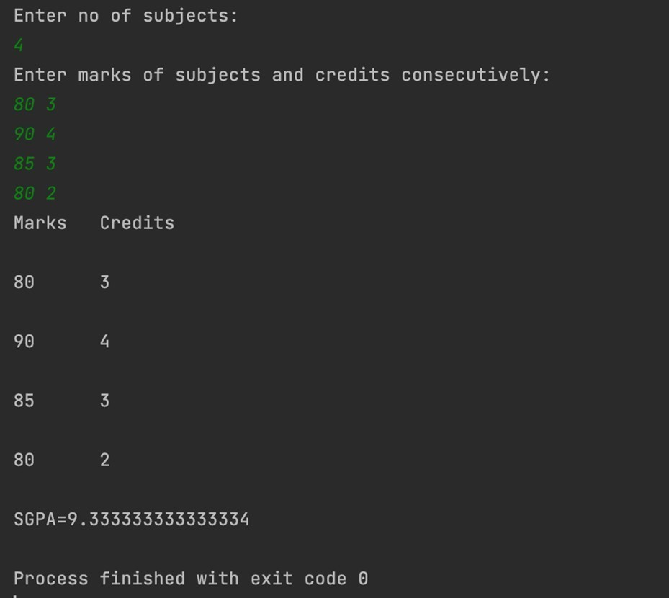

12

**Lab Program 3:**

# Create a class Book which contains four members: name, author, price, num_pages. Include a constructor to set the values for the members. Include methods to set and get the details of the objects. Include a toString( ) method that could display the complete details of the book. Develop a Java program to create n book objects.

import java.util.Scanner; public class BookDetails{

public static void main(String args[]){

Scanner scanner = new Scanner(System.in); int noPage;

double price; String title; String author; int noBooks;

System.out.println("Enter the number of books"); noBooks = scanner.nextInt();

Book book[] = new Book[noBooks]; for(int i = 0; i<noBooks; i++){

System.out.println("Enter the book title");

title = scanner.next();

System.out.println("Enter the book author"); author = scanner.next();

System.out.println("Enter the book price"); price = scanner.nextDouble();

System.out.println("Enter the number of pages in the book"); noPage = scanner.nextInt();

book[i] = new Book(); book[i].setTitle(title); book[i].setAuthor(author); book[i].setPrice(price); book[i].setPage(noPage);

}

13

for(int i = 0; i<noBooks; i++){ System.out.println(book[i]);

}

}

}

class Book{

String title; String author; double price; int noPage;

Book(){

title = "Default"; author = "Default"; price = 0.0;

noPage = 0;

}

//setters

public void setTitle(String title){ this.title = title;

}

public void setAuthor(String author){ this.author = author;

}

public void setPrice(double price){ this.price = price;

}

public void setPage(int noPage){ this.noPage = noPage;

}

//getters

public String toString(){

return title+"\t"+author+"\t"+price+"\t"+noPage;

}

}

14

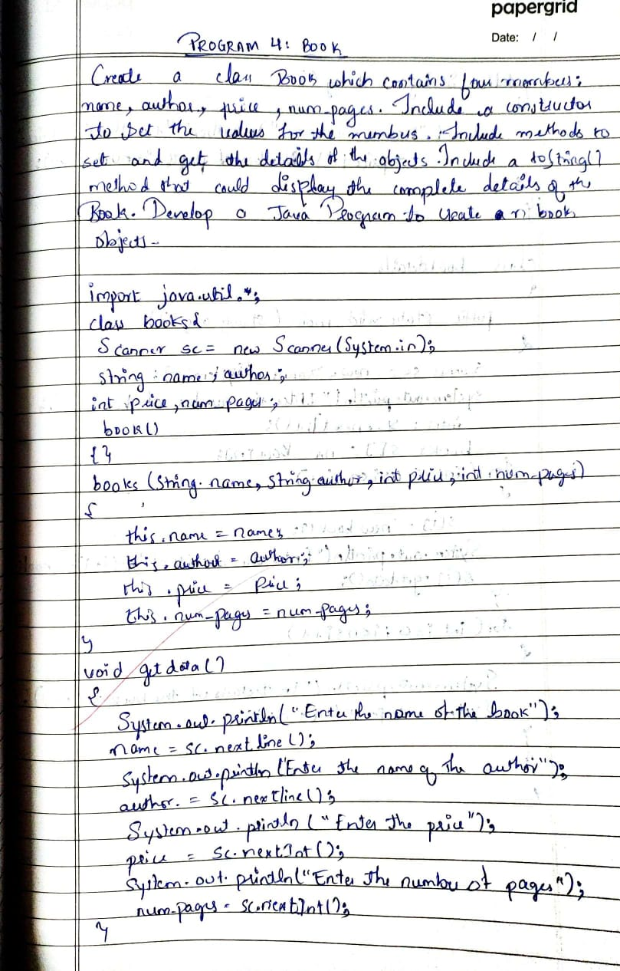

15

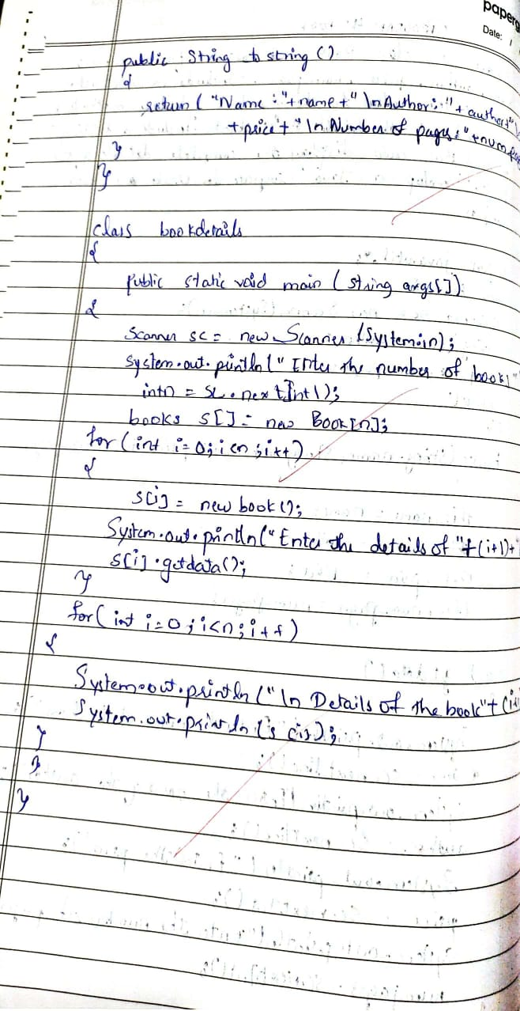

16

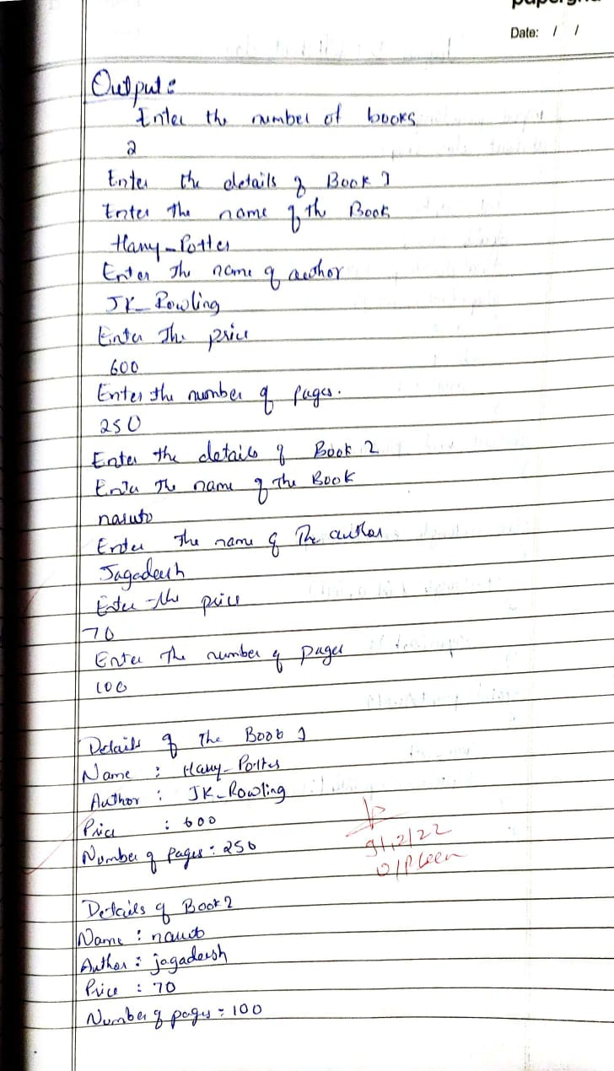

17

Output:

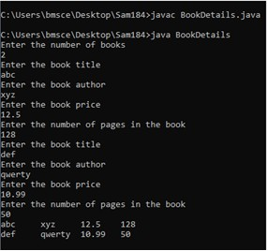

18

# Lab Program 4:

**Develop a Java program to create an abstract class named Shape that contains two integers and an empty method named printArea( ). Provide three classes named Rectangle, Triangle and Circle such that each one of the classes extends the class Shape. Each one of the classes contain only the method printArea( ) that prints the area of the given shape.**

class AbstractRunner{

public static void main(String args []){ Rectangle r = new Rectangle(5, 10); Triangle t = new Triangle(5,10); Circle c = new Circle(5);

r.printArea(); t.printArea(); c.printArea();

}

}

abstract class Shape{

int a; int b;

Shape(int a, int b){

this.a = a; this.b = b;

}

public abstract void printArea();

}

class Rectangle extends Shape{ Rectangle(int a, int b){

super(a, b);

}

public void printArea(){

System.out.println(a * b);

}

}

class Triangle extends Shape{ Triangle(int a, int b){

19

super(a, b);

}

public void printArea(){

System.out.println(0.5 * a * b);

}

}

class Circle extends Shape{ Circle(int a){

super(a, a);

}

public void printArea(){

System.out.println(3.14 * a * b);

}

}

20

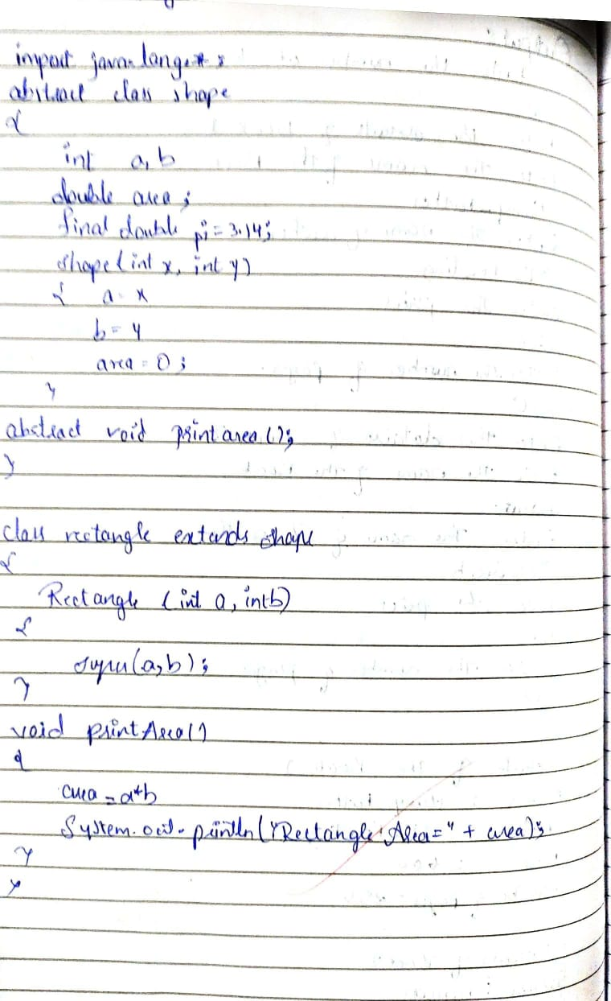

21

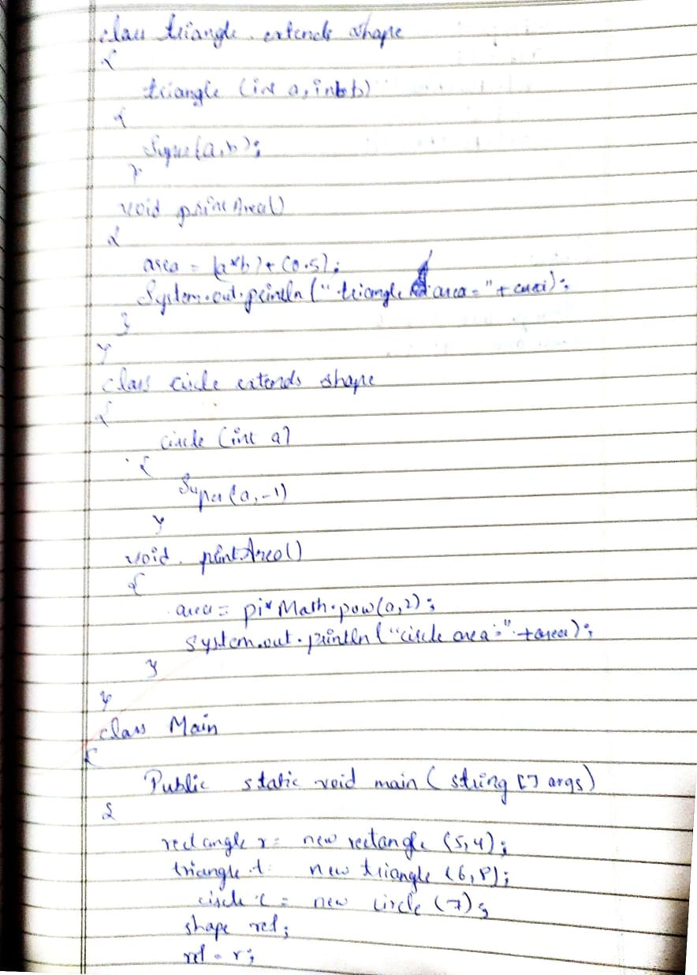

22

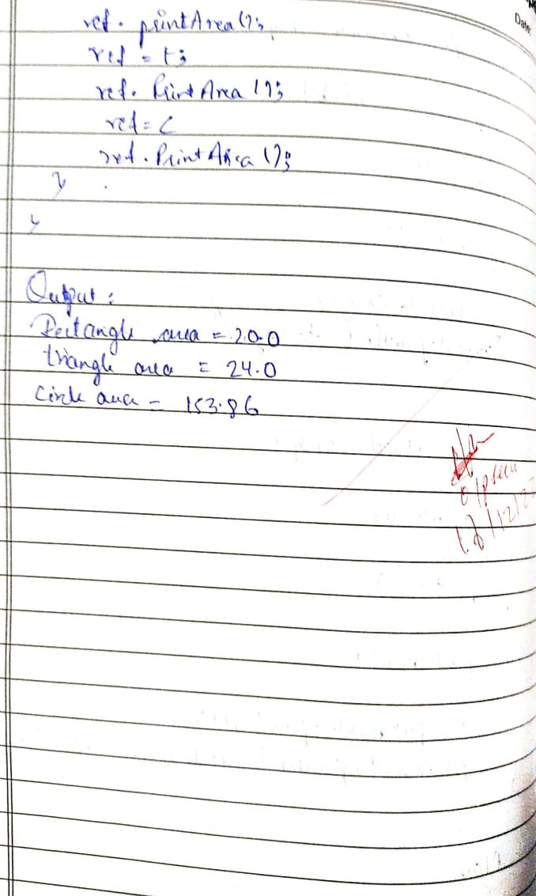

# Output:

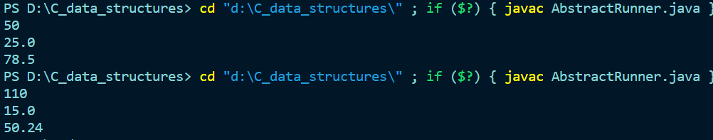

**23**

**Lab Program 5:**

**Develop a Java program to create a class Bank that maintains two kinds of account for its customers, one called savings account and the other current account. The savings account provides compound interest and withdrawal facilities but no cheque book facility. The current account provides cheque book facility but no interest. Current account holders should also maintain a minimum balance and if the balance falls below this level, a service charge is imposed.**

**Create a class Account that stores customer name, account number and type of account. From this derive the classes Cur-acct and Sav-acct to make them more specific to their requirements. Include the necessary methods in order to achieve the following tasks:**

**a) Accept deposit from customer and update the balance.**

**b) Display the balance.**

**c) Compute and deposit interest**

**d) Permit withdrawal and update the balance**

import java.lang.Math; import java.util.Scanner;

class Bank {

public static void main(String args []){

Scanner scanner = new Scanner(System.in); String name, accNo;

CurrentAccount cacc;

24

SavingsAccount sacc;

int choice;

System.out.println("Enter an option"); System.out.println("1 : Open a Savings Account"); System.out.println("2 : Open a Current Account"); choice = scanner.nextInt();

System.out.println("Enter your Name and Account NO"); name = scanner.next();

accNo = scanner.next();

switch(choice){

case 1: sacc = new SavingsAccount(name, accNo); System.out.println("Enter your starting balance"); sacc.balance = scanner.nextDouble();

int opt = 0;

System.out.println("1 : Deposit"); System.out.println("2 : Withdraw"); System.out.println("3 : Display Balance"); System.out.println("4: Quit");

while(opt != 4){

System.out.println("Select an option"); opt = scanner.nextInt();

switch(opt){

25

to deposit");

to withdraw");

case 3:

case 1: System.out.println("Enter the amount you want

double damount = scanner.nextDouble(); sacc.deposit(damount);

break;

case 2: System.out.println("Enter the amount you want

double wamount = scanner.nextDouble(); sacc.withdraw(wamount);

break;

sacc.display(); sacc.interestCalculator(1); break;

case 4: break;

}

}

break;

case 2: cacc= new CurrentAccount(name, accNo); System.out.println("Enter your starting balance"); cacc.balance = scanner.nextDouble();

opt = 0;

System.out.println("1 : Deposit"); System.out.println("2 : Withdraw"); System.out.println("3 : Display Balance"); System.out.println("4: Quit");

26

while(opt != 4){

System.out.println("Select an option"); opt = scanner.nextInt();

switch(opt){

case 1: System.out.println("Enter the amount you want to deposit"); double damount = scanner.nextDouble();

cacc.deposit(damount); break;

case 2: System.out.println("Enter the amount you want to withdraw"); double wamount = scanner.nextDouble(); cacc.withdraw(wamount);

break;

case 3:

cacc.display(); break;

case 4: break;

}

}

break;

}

}

}

abstract class Account {

String customerName;

27

String accountNumber; int accountType;

double balance = 0;

Account(String customerName, String accountNumber, int accountType) { this.customerName = customerName;

this.accountNumber = accountNumber; this.accountType = accountType;

}

abstract public void withdraw(double amount); public void deposit(double amount) {

balance += amount;

System.out.println("Your Balance is : " + balance);

}

public void display() { System.out.println("Balance is:" + balance);

}

}

class SavingsAccount extends Account { final double rateOfInterest = 0.06; final int term = 4;

SavingsAccount(String customerName, String accountNumber) { super(customerName, accountNumber, 1);

}

public void withdraw(double amount) {

28

if ((balance - amount) > 0.00) balance -= amount;

else

System.out.println("Insufficient Balance"); this.display();

}

public void interestCalculator(int period) {

double principal = this.balance, interestEarned;

double quarterlyInterest = rateOfInterest / term; double quarterlyPeriod = period * term;

interestEarned = principal * Math.pow((1 + quarterlyInterest), quarterlyPeriod) -

principal;

System.out.println("Interest earned for this balance (compounded quarterly) for one year is :" + interestEarned);

}

}

class CurrentAccount extends Account { final double penaltyPercent = 0.10;

final double minimumBalance = 5000.00; CurrentAccount(String customerName, String accountNumber) {

super(customerName, accountNumber, 2); System.out.println("Cheque book has been issued");

}

public void withdraw(double amount) {

29

if ((balance - amount) > 0.00) balance -= amount;

else

imposed");

System.out.println("Insufficient Balance"); this.display();

if (balance < minimumBalance){

System.out.println("A penalty of " + balance*penaltyPercent + "has been

balance -= balance * penaltyPercent;

} } }

30

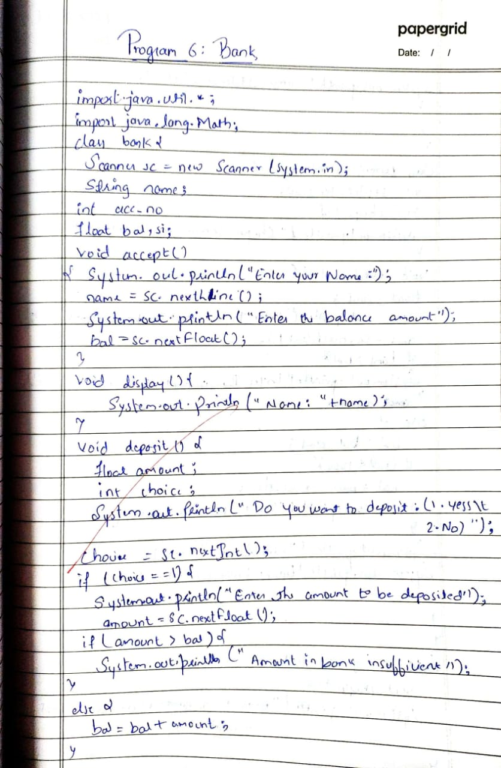

31

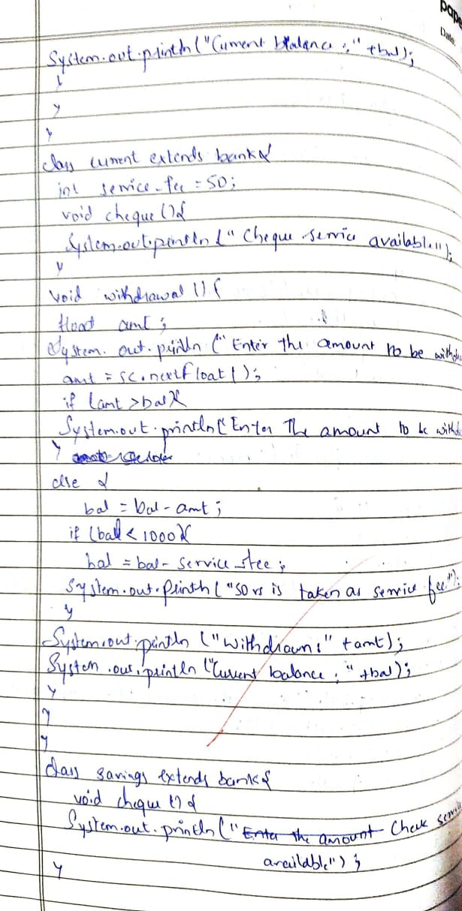

32

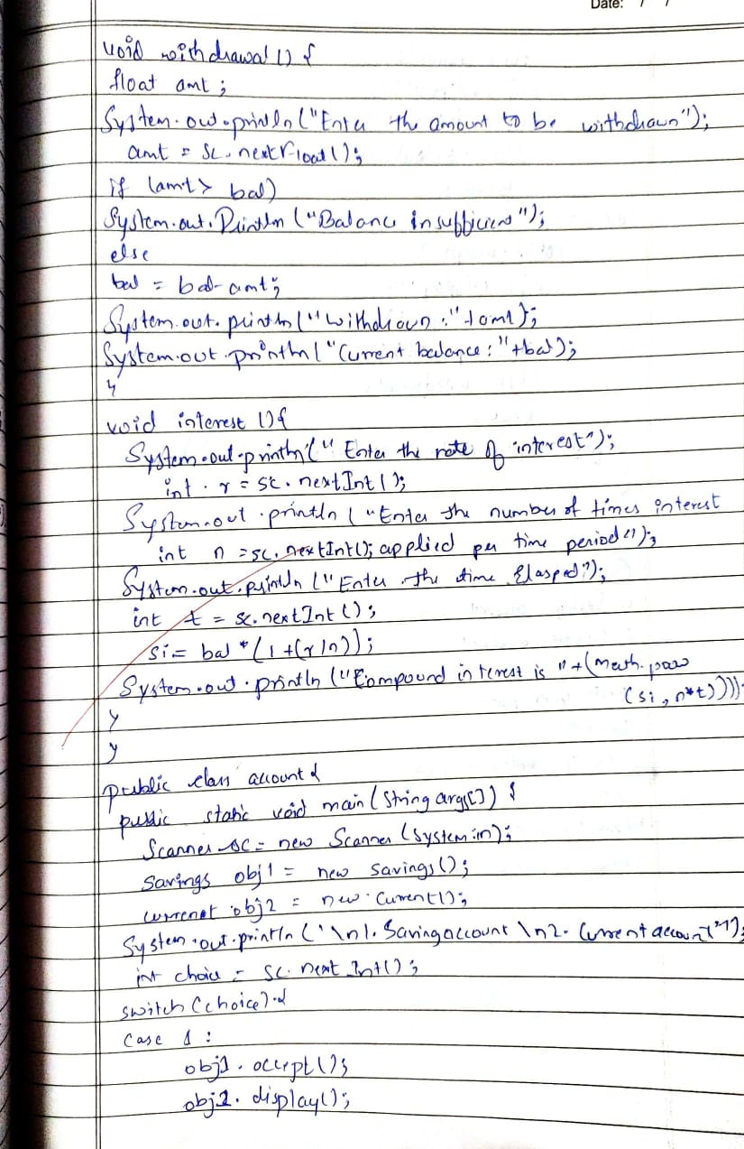

34

33

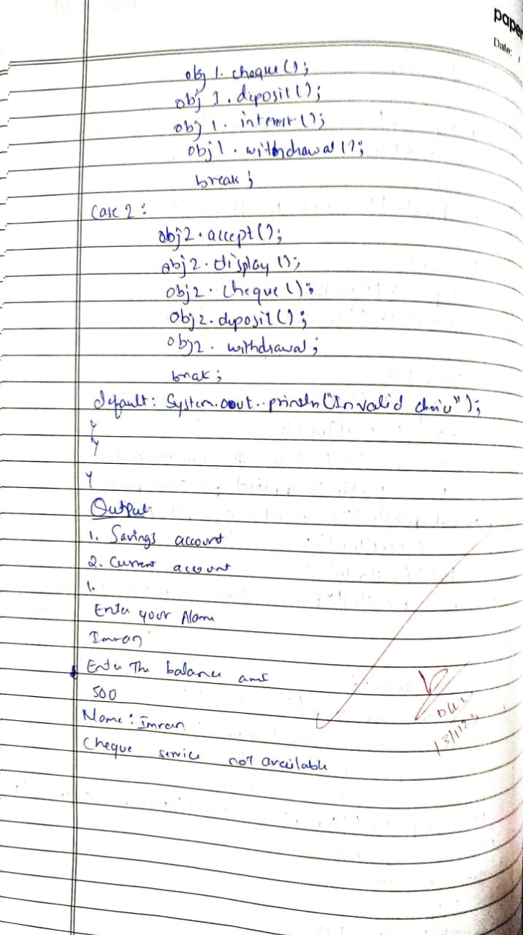

34

37

38

# Output:

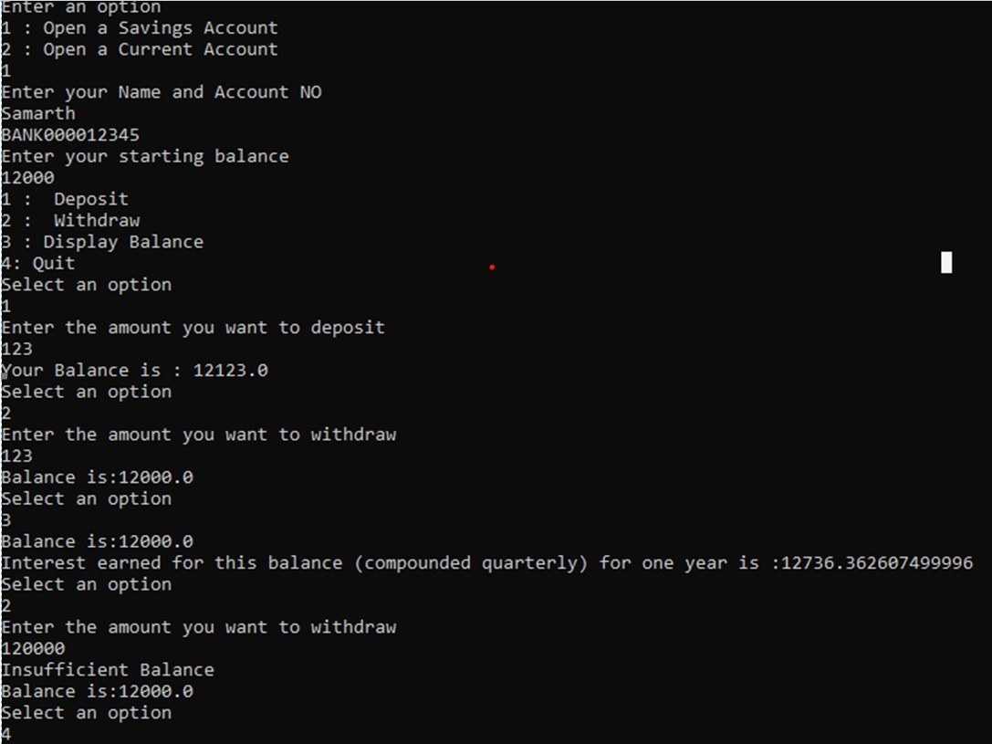

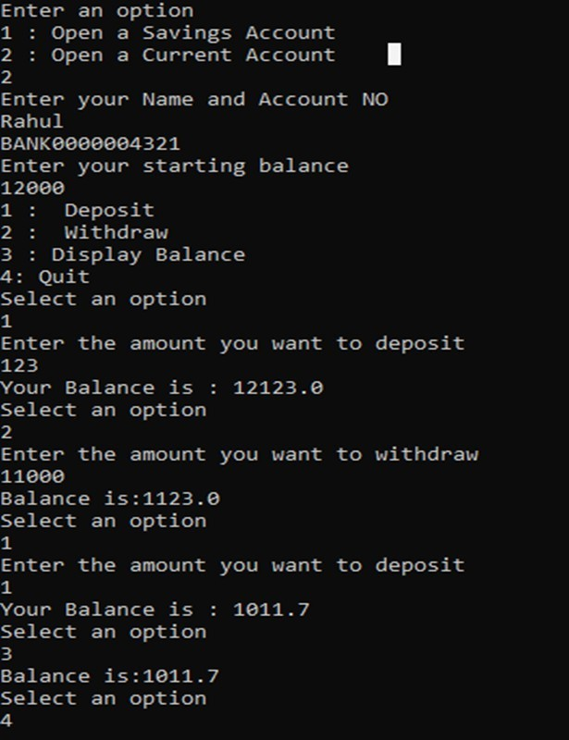

**Lab Program 6:**

# Write a program that creates a user interface to perform integer divisions. The user enters two numbers in the text fields, Num1 and Num2. The division of Num1 and Num2 is displayed in the Result field when the Divide button is clicked. If Num1 or Num2 were not an integer, the program would throw a NumberFormatException. If Num2 were Zero, the program would throw an Arithmetic Exception Display the exception in a message dialog box.

import java.util.Scanner;

public class InterfacedScoreCalc {

public static void main(String[] args) { Scanner scanner = new Scanner(System.in);

Student student; int opt = 0;

System.out.println("Choose an option\n1.UnderGraduate\n2.Graduate"); opt = scanner.nextInt();

switch(opt){

case 1: System.out.println("Enter your name");

student = new UndergraduateStudent(scanner.next()); System.out.println("Enter your marks");

for(int i = 0; i<4; i++){

student.setTestScore(i, scanner.nextInt());

}

System.out.println("Student Name: " + student.getStudentName()); System.out.println("Result: " + student.getTestResult());

break;

case 2: System.out.println("Enter your name");

student = new GraduateStudent(scanner.next()); System.out.println("Enter your marks");

for(int i = 0; i<4; i++){

student.setTestScore(i, scanner.nextInt());

}

System.out.println("Student Name: " + student.getStudentName()); System.out.println("Result: " + student.getTestResult());

break;

}

} }

interface StudentFunctions{ void generateResult();

}

abstract class Student implements StudentFunctions{ String studentName;

int[] testScores = new int[4]; String testResult; Student(String studentName) {

this.studentName = studentName;

testResult = "Default";

}

abstract public void generateResult();

void setTestScore(int testNumber, int testScore)

{ testScores[testNumber] = testScore;

}

String getStudentName() { return this.studentName;

}

void setStudentName(String studentName) { this.studentName = studentName;

}

int[] getTestScores()

{ return this.testScores;

}

String getTestResult()

{ this.generateResult(); return testResult;

}

void setTestResult(String testResult) { this.testResult = testResult;

}

}

class UndergraduateStudent extends Student { UndergraduateStudent(String studentName) {

super(studentName); }

@Override

public void generateResult() { int a[] = this.getTestScores(); int sum

= 0;

for (int i = 0; i < 4; i++) { sum += a[i];

}

int avg = sum / 4; if (avg >= 60)

this.setTestResult("Pass"); else

this.setTestResult("Fail");

}

}

class GraduateStudent extends Student { GraduateStudent(String studentName) {

super(studentName);

}

@Override

public void generateResult() { int a[] = this.getTestScores(); int sum

= 0;

for (int i = 0; i < 4; i++) { sum += a[i];

}

int avg = sum / 4; if (avg >= 70)

this.setTestResult("Pass"); else

this.setTestResult("Fail");

}

}

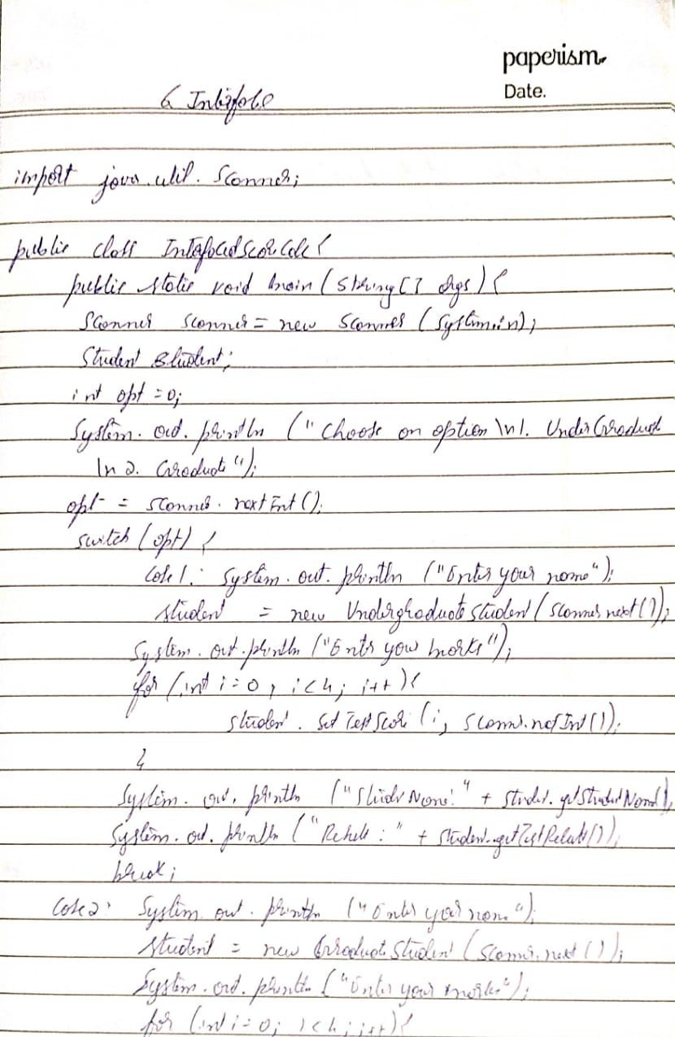

46

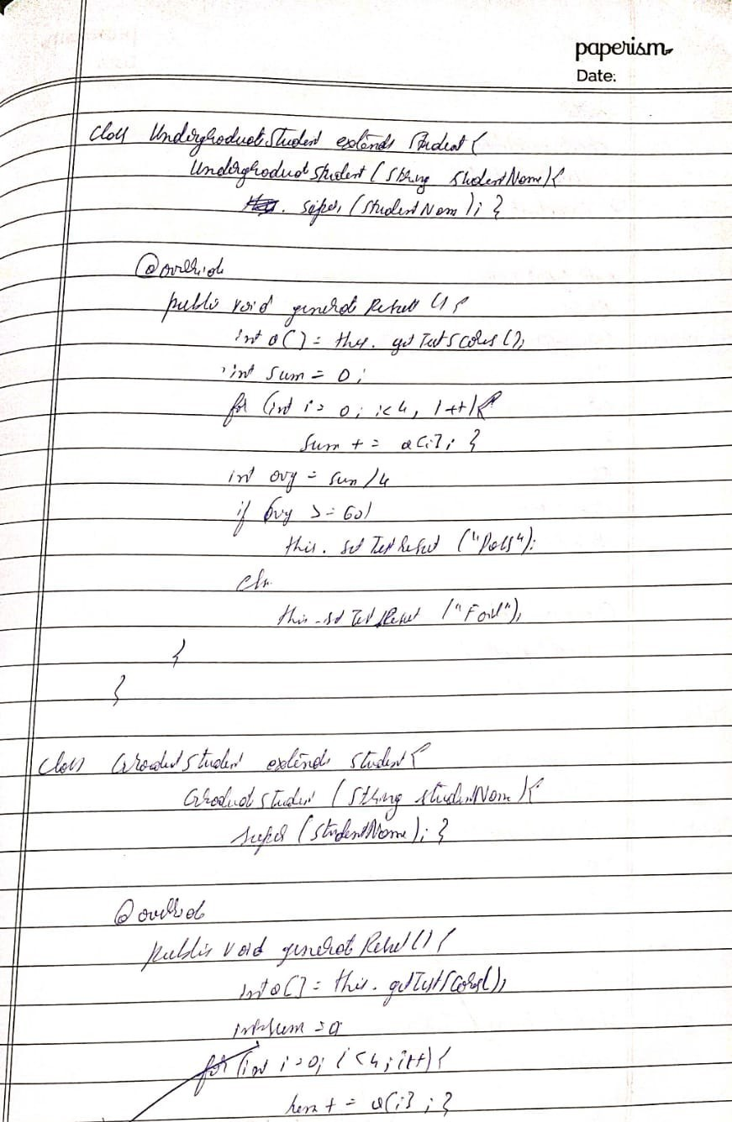

47

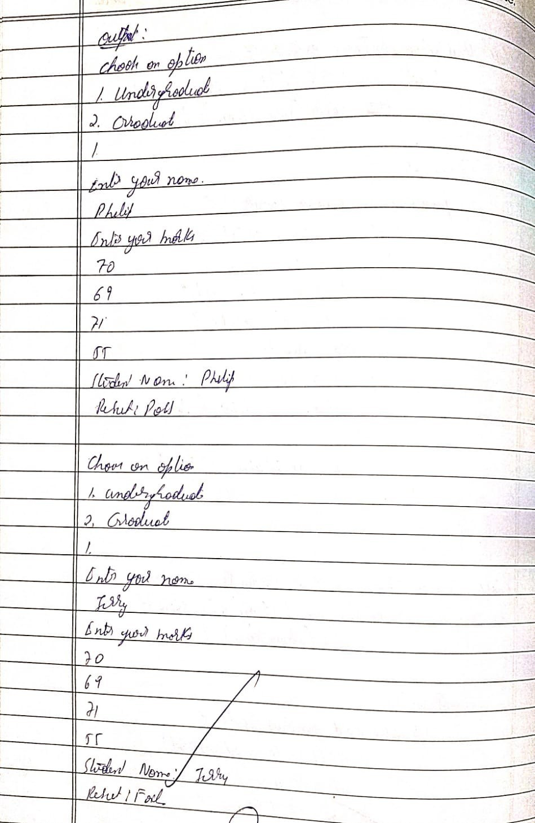

48

# Output:

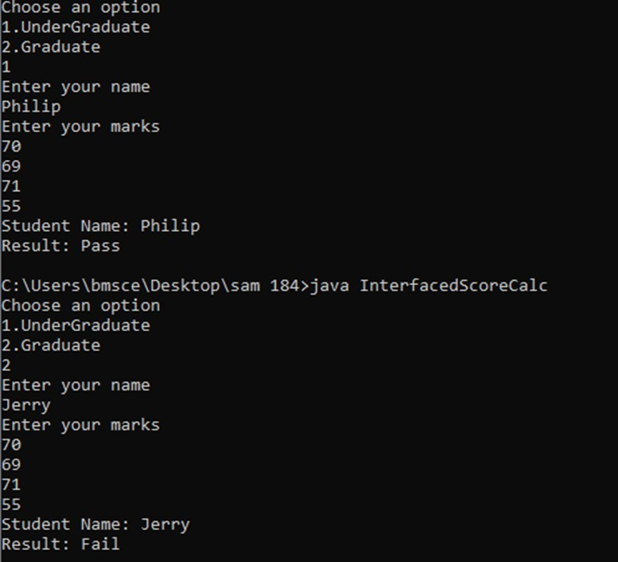

**Lab Program 7:**

# Write a program that demonstrates handling of exceptions in inheritance tree. Create a base class called “Father” and derived class called “Son” which extends the base class. In Father class, implement a constructor which takes the age and throws the exception WrongAge( ) when the input age<0. In Son class, implement a constructor that cases both father and son’s age and throws an exception if son’s age is >=father’s age.

import java.util.Scanner;

class WrongAgeException extends IllegalArgumentException{ WrongAgeException(){};

WrongAgeException(String some){ super(some);

}

}

class Father{

int ageFather; Father(){}

Father(int ageFather) throws WrongAgeException{ if(ageFather<=0){

throw new WrongAgeException("Age should be greater than zero!");

}

this.ageFather = ageFather;

}

}

class Son extends Father{ int ageSon; Son()

{}

Son(int ageFather, int ageSon) throws WrongAgeException{ super(ageFather); if(ageFather <= ageSon){

throw new WrongAgeException("Age of son can't be greater than Father's

age!!!");

}

}

}

this.ageSon = ageSon;

class ExceptionInheritTree{

public static void main(String args[]){

Scanner sc = new Scanner(System.in); int ageFather, ageSon; System.out.println("enter age of father and son"); ageFather = sc.nextInt();

ageSon = sc.nextInt(); try{

son.ageSon);

}

Son son = new Son(ageFather, ageSon);

System.out.println("Father's age: " + son.ageFather + "\n" + "Sons's age: " +

catch(WrongAgeException wae){ System.out.println(wae);

System.out.println("Exception caught in main!#!");

}

}

}

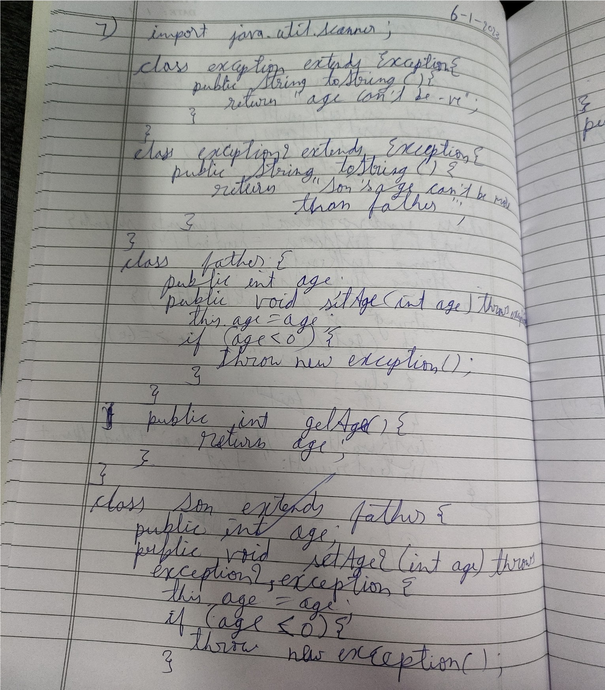

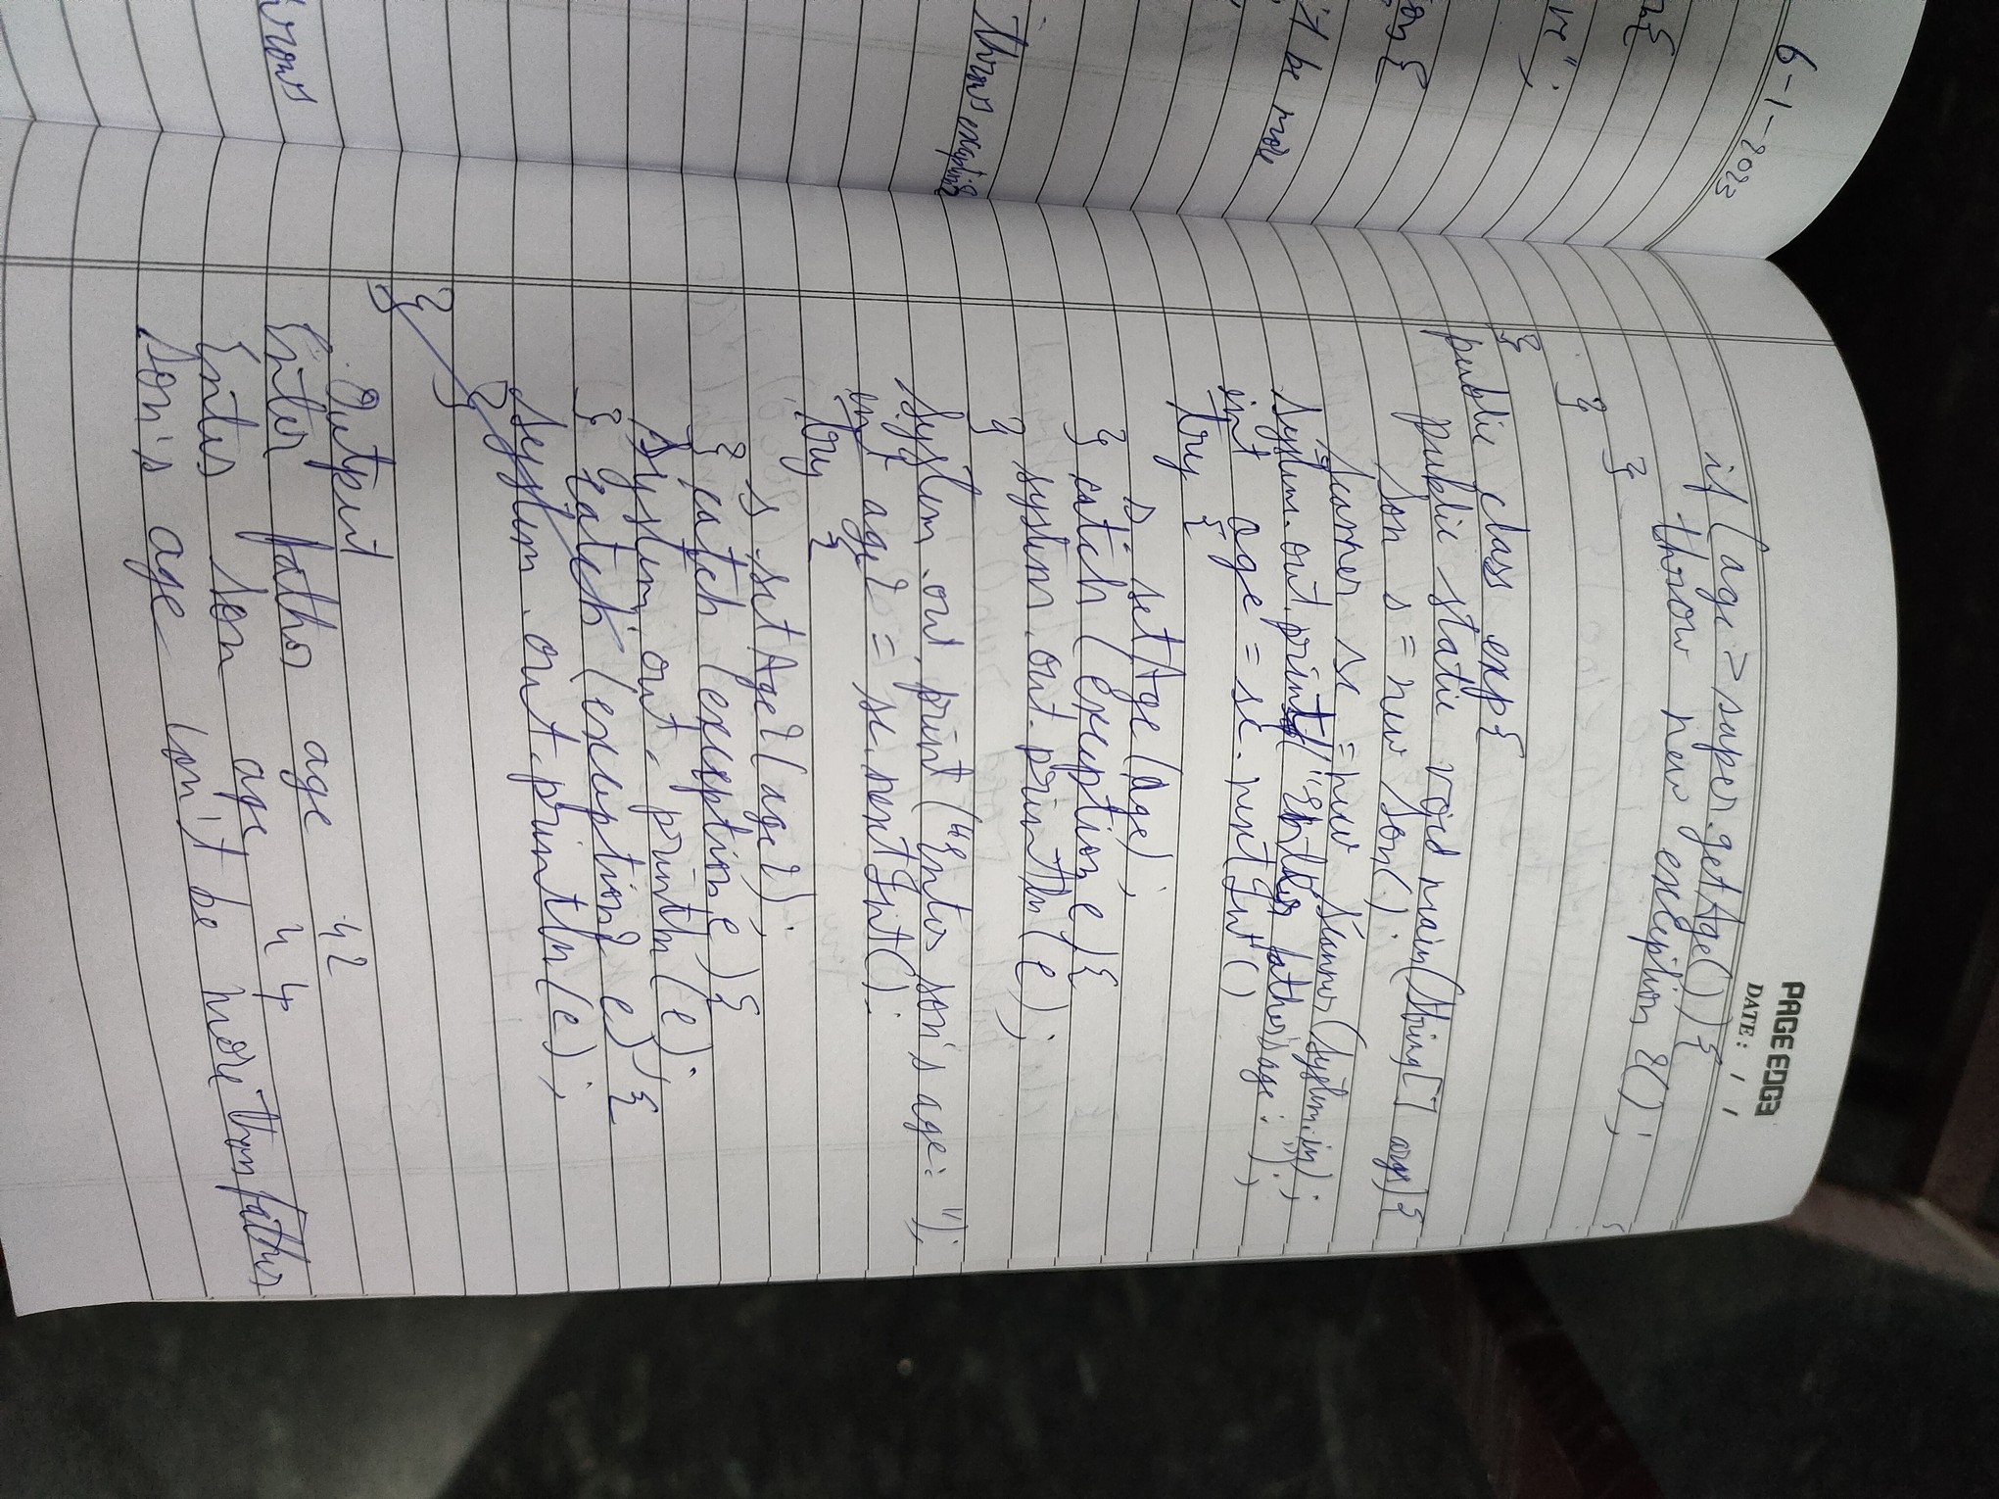

output:

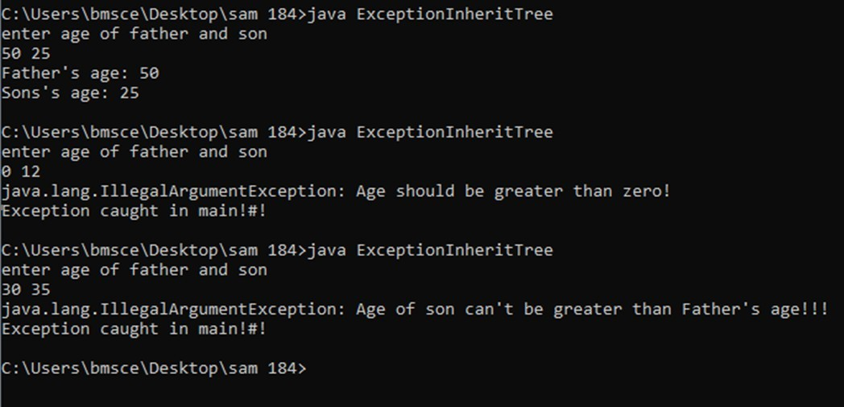

# Lab Program 8:

**Write a program which creates two threads, one thread displaying “BMS College of Engineering” once every ten seconds and another displaying “CSE” once every two seconds.**

class MyThread extends Thread { long time;

private volatile boolean running = true;

MyThread() {

System.out.println("Default");

}

MyThread(String name, long time) { super(name);

this.time = time;

}

public void pause() {

running = false;

}

public void run() { try {

while (running) {

System.out.println(this.getName()); Thread.sleep(time * 1000);

}

} catch (InterruptedException ie) { System.out.println("Exception caught in method");

}

}

}

class ThreadRunner {

public static void main(String[] args) {

MyThread mt1 = new MyThread("BMS", 10); MyThread mt2 = new MyThread("CSE", 2); mt1.start();

mt2.start(); try {

Thread.sleep(20 * 1000); mt1.pause();

mt2.pause();

} catch (InterruptedException ie) {

System.out.println("Exception caught in main"); }}}

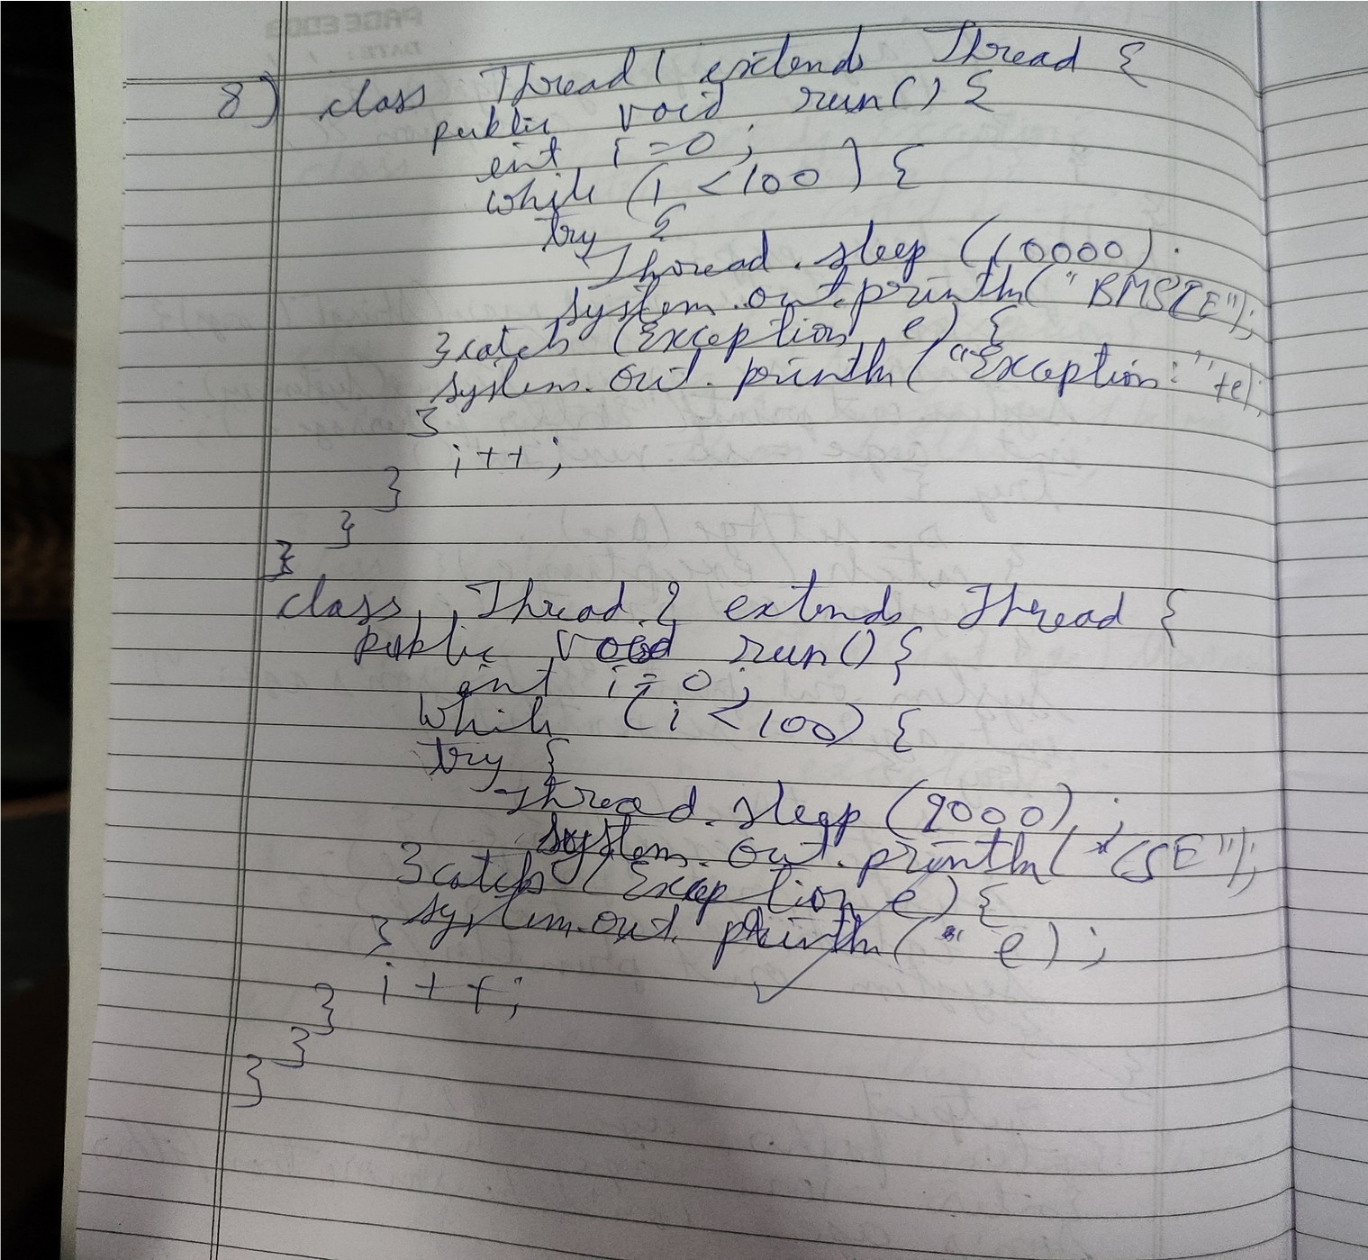

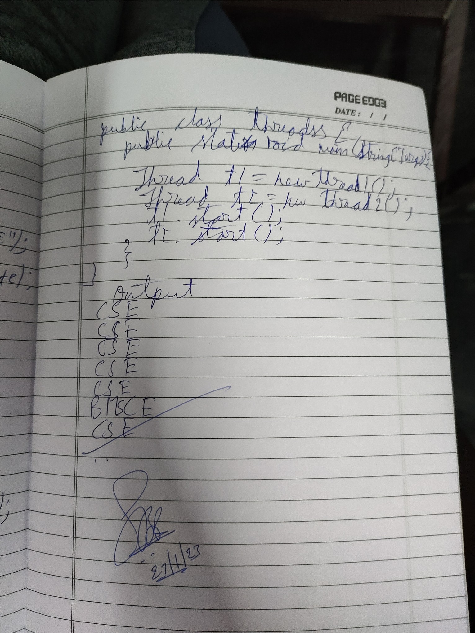

56

**Output:**

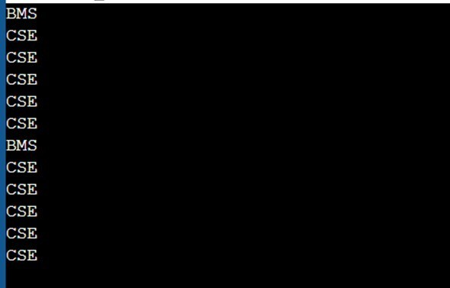

57